**Emerging Methods for Early Detection of Forest Fires**

**PROJECT DEVELOPMENT PHASE**

**TEAM ID - PNT2022TMID45424**

**DELIVERY OF SPRINT -4**

Due to low spatial resolution and low temporal resolution, satellite images cannot be used for wildfire detection. However, UAV gives high-resolution images and is cost-effective for wildfire detection. It gives a proposed architecture of forest fire detection and monitoring system based on UAV. The basic elements of the UAV-based forest fire system cover functions of monitoring (gives the potential of fire), detection (gives a triggering alarm), diagnosis and prognosis, which are initialized by fire operators after getting the triggering alarm. The main function of the diagnosis is to find detailed information regarding the location and extent of the fire. And also track its evolution whereas in prognosis it tracks and predicts the evolution of future fire in real-time using information (wind and fire conditions) provided by onboard remote monitoring sensors that are installed on UAV. These functions can be carried out with the help of single UAV, or by a group of UAVs (with multiple sensors having different functions) along with the central ground station. The main aim of using UAV is to predict the occurrence of fire, track its location, and to give real-time information to fire-fighters or execute its operation with UAV. To acquire these goals UAV-based system includes (i)

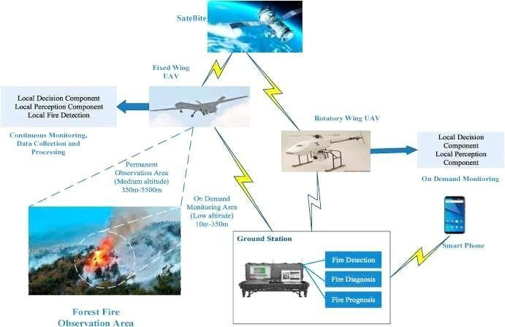 various sensors, GPS receivers, cameras, Inertial Measurement Units (IMUs),

(ii) algorithms and strategies, (iii) autonomous Guidance Navigation and Control (GNC), (iv) localization, deployment and control system, and (v) groundstation.